SKYCREST ELEMENTARY SCHOOL
2025-2026 STUDENT HANDBOOK

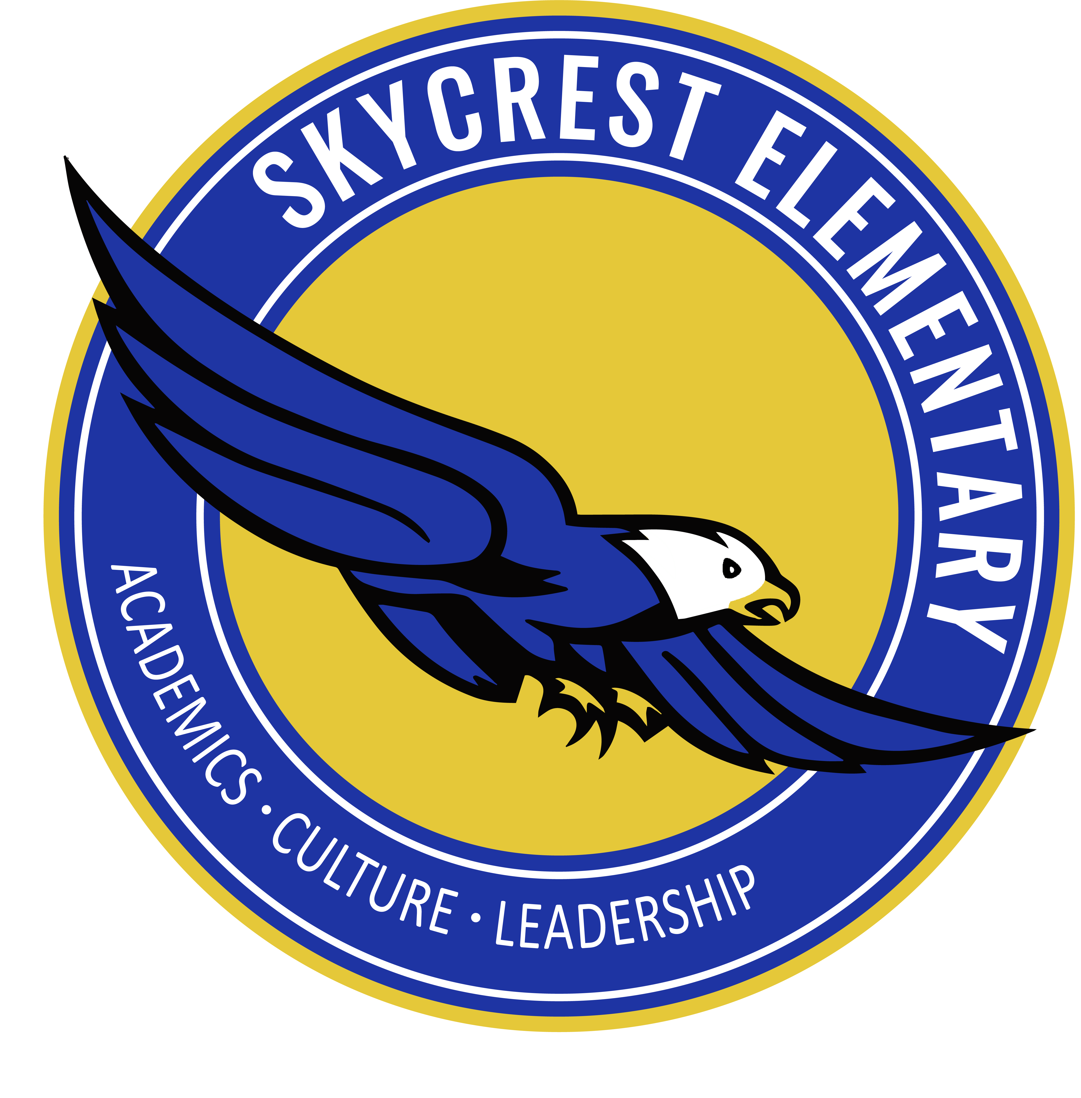
School Board of Pinellas County
Lisa N. Cane - Chairperson, At Large District #2
Katie Blaxberg – Single Member District #5
Caprice Edmond - Single Member District #7
Laura Hine - Chairperson, At Large District #1
Eileen M. Long - Single Member District #4
Stephanie Meyer - Single Member District #6
Dawn M. Peters - At Large District #3

Mr. Kevin Hendrick - Superintendent of Schools _______________________________________________________________________________

Skycrest Elementary School
10 North Corona
Clearwater, Florida 33765
727-469-5987
School hours for 2025-2026: 8:45 a.m. – 2:55 p.m.
Anne Caparaso – Principal
Stephanie Wignall- Assistant Principal

Skycrest Vision:
100% Student Success

Skycrest Mission:
Inspiring Greatness through Academics, Culture, and Leadership

Welcome to Skycrest Elementary School! The staff appreciates your assistance and cooperation in making this a very enjoyable and productive year in your child’s life. The information in this packet is designed to answer some of your questions regarding our general school policies and procedures. Changes may be necessary, and we will notify you of any policy changes by phone and/or email messages, memos and/or in our monthly newsletter.

If you have a question that has not been covered in this handbook or in the Pinellas County Code of Student Conduct, please feel free to call the school. We look forward to having a great year!

Skycrest Elementary School
Student—Parent—Teacher Compact
2025-2026

A pledge is a voluntary agreement designed to provide a partnership between home and school.
The Parent—Student—Teacher Pledge meets the requirement of the Title I Federal Guidelines.

Successful schools are the result of students, families, and educators working together.

As a STUDENT, I pledge to: | As a PARENT, I pledge to: | As a TEACHER, I pledge to:
- Eagle Guidelines for Success will be followed (SOAR):  Safe  On task  Accountable  Respectful  - Arrive on time, prepared, dressed in a school uniform, and ready to learn.  - Give my family the planner and/or any student work/papers to review.  - Lead a student-led conference with a family member to share my progress.  - Every day, I will read and complete my homework.  - Self-motivated learner by fostering the 7 Habits of Healthy Kids.   | - Ensure my child attends school every day on time, well-rested and ready to learn.  - Acknowledge and support the school’s effort to develop positive behavior.  - Give my child praise and encouragement when reviewing assignments and homework.  - Look at my child’s planner to sign and have communication with my child’s teacher.  - Ensure my child is dressed according to the Skycrest school uniform dress code policy.  - Support the school by participating in parent-teacher conferences, family engagement nights, and PTA/SAC.  Parent Contact Info:  Name: ________________________  Phone: _  Email: _ | - Establish and maintain open communication with families.  - Always maintain a safe, positive learning environment where ALL students are valued.  - Grades will be posted and updated in FOCUS in a timely manner.  - Learn new instructional strategies to improve my practice.  - Ensure to teach the 7 Habits and School-wide Guidelines for Success and classroom expectations regularly. (SOAR)  - Schedule a MINIMUM of one conference with the family to share student progress.  Conference Date #1: ______#2:______ Family Initials: _____ __  Teacher Initials: ___ __  Teacher Contact Info:  Phone: _________ _  Email: ________ _

Student Signature Date

Parent/Guardian Signature Date

Teacher Signature Date

Escuela Elemental de Skycrest
Contrato de Estudiantes—Padres—Maestros
2025-2026

Un compromiso es un acuerdo voluntario diseñado para proporcionar una asociación entre el hogar y la escuela.
El compromiso de padres, estudiantes y maestros cumple con los requisitos de las pautas federales del Título I.
Las escuelas exitosas son el resultado del trabajo conjunto de estudiantes, familias y educadores.

Como ESTUDIANTE, me Comprometo a: | Como PADRE me Comprometo a: | Como Maestro me Comprometo a:
- Seguiré las pautas de Eagle para el Éxito (SOAR).  Safe  On task  Accountable  Respectful  - Asegurarme de llegar a la escuela a tiempo, preparado, vestido con el uniforme escolar y listo para aprender.  - Dar a mis padres la agenda, o cualquier otro documento y trabajo escolar para que lo revisen.  - Llevar a cabo una conferencia dirigida por el estudiante con mis padres o familiares para compartir mi progreso.  - Todos los días, llevare un libro a casa, leeré o me leerán por lo menos 30 minutos y responderé según indicaciones de mi maestro.  - Aprenderé de forma auto motivada desarrollando una mentalidad de crecimiento, a través de pensar, participar y trabajar juntos. | - Me asegurare que mi hijo/a asista a la escuela todos los días, llegar a tiempo, bien descansado y listo para aprender  - Reconocer y apoyar el esfuerzo de la escuela para desarrollar un comportamiento positivo  - Darle a mi hijo/a elogios y estímulos cuando revise las tareas y los deberes.  - Checar la agenda de mi hijo/a para revisar las tareas escolares, firmar la agenda diariamente y tener una línea de comunicación abierta con el maestro de mi hijo/a.  - Me asegurare de que mi hijo/a este vestido apropiadamente de acuerdo con la política de código de vestimenta del uniforme escolar de Skycrest.  - Apoyare a la escuela participando en conferencias de padres y maestros, noches de participación familiar en talleres, PTA/SAC.  Información del Padres/tutor: Nombre: _______________________  teléfono: ______________________  CORREO ELECTRONICO:  ______________________________ | - Establecer y mantener líneas abiertas de comunicación con las familias.  - Mantener siempre un ambiente de aprendizaje seguro y positivo donde todos los estudiantes donde se valore a todos los estudiantes.  - Las calificaciones serán publicadas y actualizadas en FOCUS de manera oportuna.  - Aprender nuevas estrategias de instrucción para mejorar mis prácticas en la enseñanza de los estándares para el éxito de los estudiantes.  - Asegurar de enseñar/reproducir las normas para el éxito y las expectativas del aula en toda la escuela con regularidad. (SOAR)  - Programar un mínimo de una conferencia con la familia para compartir el progreso del estudiante.  Fecha de la Conferencia #1: __  Iniciales de familia:  Iniciales del maestro:  Fecha de la Conferencia #2: Iniciales de FAMILIA:  Iniciales del maestro:

Firma del Estudiante Fecha

Firma del Padre o Guardian Fecha

Firma del Maestro/a Fecha

Arrival and Dismissal Procedures

School Hours: 8:45 a.m. - 2:55 p.m.

Student Code of Conduct Parental Responsibilities (Policy 5500.01)
Will NOT leave their child at school more than thirty (30) minutes before the start of the school day or pick their child up more than thirty (30) minutes after the school day unless the parent has made special arrangements with a teacher, administrator, or before/after school care program. Supervision will not be provided beyond that time. This also includes school activities outside the regular school day such as clubs, dances, carnival, practices, and games.

Because of this policy, any student who is late being picked up 30 minutes after dismissal, will receive a warning letter. After the third time of being late, campus police will be called to pick up your child.

Students will be dismissed from the office only after parent or guardian has signed the student out. Students are not to be dismissed after 2pm to not interfere with dismissal. Parent/Guardian will need a picture ID for student to be released.

Absences and Tardiness

Absences can be reported using the Absent Online Reporting System from the school’s website, calling the front office, or sending an email to your child’s teacher. Within 48 hours of the student’s return to school, they are to bring a note indicating the reason for the absence and be signed by a parent/guardian. If a student is absent more than three consecutive days, parents are required to call and provide a doctor’s note.

A student is tardy when the student is not in his or her assigned seat at 8:45 a.m. Examples, but not limited to, of an unexcused tardy include:
- Oversleeping, missing the school bus, shopping/pleasure trips, car problems (ex., flat tire, no gas, car will not start), traffic, returned home for forgotten items, hair appointments.

Habitual tardiness is unacceptable and unfair to the other students because instruction is interrupted every time a late student arrives. When a student is more than thirty minutes late, the state requires schools to code the tardy as “extreme tardy”. Numerous incidents of early sign out are unacceptable and unfair to the other students whose instruction is interrupted each time a student is dismissed early.
**All students must be signed into the office by an adult after 8:45 am.

Unexcused Absences
Any absence which does not meet the criteria of an excused absence is an unexcused absence. The following are examples of unexcused absences:
- Out of school suspension
- Family vacation

A letter shall be sent to the parent or guardian and a referral will be made to the school’s Child Study Team for a student who has had at least 5 unexcused absences, or absences for which the reasons are unknown, within a calendar month, or 10 unexcused absences, or absences for which the reasons are unknown, within a 90-calendar day period.

Parent responsibility

Parents must keep the school advised of current addresses, employment and emergency phone numbers. Tell the school principal if there is a change in residence or custody of the student, even if the parent thinks the student is still in the school’s attendance zone. The parent must tell the principal within five (5) days of the change. If the school discovers that the parent has moved and the parent has not told them, their child could be considered to be “found out of that school’s attendance zone”. This could mean an immediate change of school for their child and their child could be deemed ineligible for athletics and other activities.

Child Care

YMCA will offer a program in the morning and afternoon. Please call: 727-467-9622. Also, there are other before and after care programs that drop off and pick up students in Vans. Call the front office or visit the Skycrest website for more information.

Breakfast & Lunch Program

The cafeteria serves breakfast and lunch each day. Breakfast and lunch are free for all Skycrest students; however, they must arrive before 8:35 a.m. so that they are not late to class and marked tardy.

School-wide Behavior Plan

The primary objective of the Skycrest Elementary School Behavior Plan is to provide an optimum educational opportunity for each child in school. Skycrest promotes a positive approach to discipline and uses the online PBIS Reward program. We encourage all families to view this program on a regular basis to view students’ point and any incidents. Pinellas County has implemented a restorative practices program throughout all schools.

Restorative practices involve strategies based on a mindset that maximizes building positive relationships to build a pro-social community through interactions that empower students to have a voice, to practice appropriate emotional expression, to experience empathy for one another, and to accept accountability.
When harm occurs, there are processes to repair the harm to the relationship. The following are restorative questions that explore what happened and how to make things right for all involved:

When challenging behavior:  - What happened?  - What were you thinking of at the time?  - What have you thought about since?  - Who has been affected by what you have done?  - In what way have they been affected?  - What do you think you need to do to make things right? | To help those affected:  - What did you think when you realized what had happened?  - What impact has this incident had on you and others?  - What has been the hardest thing for you?  - What do you think needs to happen to make things right?
For more information about Restorative Practices in Pinellas County Schools, please visit https://www.pcsb.org/rp

School Wide Guidelines for Success:

- S - Safe
- O – On task
- A – Accountable
- R - Respectful

School-wide Behavior Responses - (Violation of expectations will be dealt with on an individual basis) Consequences may include:

- Alternative consequences with parent permission (example- complete acts of kindness, help another class,etc.)
- Minor referral documented in the PBIS Reward program
- Individual conference with the principal or school counselor
- Required parent, child, teacher, principal conference
- Major referral written for child
- Suspension from school/bus
- Alternative placement (classroom or school)
- Recommendation for expulsion from school/bus

Bullying and Harassment

It is the policy of the School Board that all of its students, employees, and volunteers learn and work in an environment that is safe, secure, and free from harassment and bullying of any kind. The Board will not tolerate bullying and harassment of any type. Conduct that constitutes bullying and harassment, as defined herein, is prohibited. This policy shall be interpreted and applied consistently with all applicable State and Federal laws and the Board's collective bargaining agreements. Conduct that constitutes bullying, harassment, or discrimination, as defined herein and in F.S. 1006.147, is prohibited. For more information about the policy or bullying prevention and intervention visit the Pinellas County Schools website at https://www.pcsb.org/page/3639.

Skycrest Elementary is committed to providing a safe learning environment and will not tolerate bullying or harassment of any kind. Incidents of bullying or harassment can be reported to the administrators, Skycrest staff, or reported online at https://www.saysomething.net/. Anonymous reports can also be made by calling the Campus Crime Stoppers Hotline at 1-800-873-8477.

Policies and Procedures

Clinic

The nurse or office staff member will attend to all medication administration, prescription and over-the-counter, first aid needs, care plans, immunization validation, and medical records. All students MUST have a clinic card on file OR COMPLETE ONLINE. ALL medication must be brought by the parent (students are NOT allowed to bring medication to or from school) to the front office with proper paperwork completed. Sick students may be signed out and picked up in the front office. Parents/Guardians who need to contact the clinic may call the school at 727-469-5987.

Head Lice

The School Board has a policy to reduce the spread of lice in schools. If the student has lice or nits (egg sacs) it is district policy to send the student home and not allow them back until the student’s hair is nit free. Parents, please regularly check your child’s hair for lice. Please notify the school if you discover head lice. Students who have been sent home due to lice, must come to the front office the next day after being treated to be checked for any lice or nits. If the child is clear, he/she will be allowed to return to school. Any student with lice or nits will be allowed a maximum of three excused days unless extended by the school principal.

Health, Safety, and Physical Education

Emergency phone numbers for each child must be on file in the office. If your child has a physical problem, allergy, or any health problems, please notify the school nurse or a member of the office staff. Upon injury at school, the parents will be notified if the injury is serious. Minor injuries will be attended to at school.

Skycrest Elementary has a physical education program. Every child is expected to participate. Students will be excused by a doctor’s statement or written parent request. Parent’s written excuse is good for three days only. If a child is to be out of P.E. class longer than three days, a doctor’s excuse note is required. Please note ALL students should wear closed-toe, flat shoes to P.E.

Dress Code – Refer to the Student Code of Conduct and Skycrest website for more detailed information
This dress code is as follows:
Shirts may be polo style, crew neck T-shirts, or Skycrest Elementary t-shirts. Colors: red, forest green, navy blue, light blue or white. Hoodies allowed but must be solid color (Skycrest colors), no graphics on the shirt. Hoodies ARE NOT ALLOWED to be on a student’s head while on campus due to safety concerns.
Bottoms may be pants, shorts, skirts or skorts (must be mid-thigh length or longer). Colors: khaki, black or navy blue. Neat dark blue denim jeans (no holes or rips) are allowed, No denim shorts, skirts or skorts, or leggings allowed.
Closed-toe footwear is HIGHLY recommended due to recess and PE. Crocs ARE NOT ALLOWED.

Field Trips

Parents will be given information regarding the field trip and be required to sign a permission slip for a child to go on any off-campus trip. If there is a monetary charge for the field trip, the money must be paid on one of the two collection days. Parents often help by chaperoning field trips. However, for safety and liability reasons, preschool siblings may not go on field trips. All chaperones are required to be a registered volunteer. No child will be denied going on a field trip due to not being able to pay.

Fire, Tornado, Active Assailant, and Lockdown Drills

Fire drills and Active Assailant drills are held monthly. Practice drills for tornado watch/warning are held once a semester. Students will be taught how to participate and prepare for all drills by the classroom teacher.

Lost and Found

Items found at school should be turned in to the school office. Any lost item should be reported to the classroom teacher immediately. Name tags placed on your child’s clothing and supplies will aid in the prompt return of lost articles.

Honor Roll and Principal’s List

Procedures have been established by the School Board of Pinellas County to recognize those students who have achieved academic success. Students will be recognized as an Honor Roll or Principal’s List student if they meet the following criteria:

Honor Roll: Students in grades 3-5 who receive A’s and B’s in all academic subjects and E’s & V’s in Specials, who are performing at or above grade level and who achieve E, V, or S for conduct in all areas with no referrals, shall have their names entered on the Honor Roll.

Principal’s List: Students in grades 3-5 who receive all “A’s” in the academic subjects and all E’s in Specials, who are performing at or above grade level and who achieve E, V, or S for conduct in all areas with no referrals, shall have their names entered on the Principal’s List.

Parent-Teacher Conferences and Student-led Conferences

It is important you communicate regularly with your child's teachers and actively participate in their learning by participating in parent-teacher conferences and student-led conferences. These conferences teacher may be held before or after school hours by appointment. If you find that an appointment cannot be kept, please notify the teacher immediately either by emailing the teacher or calling the front office to relay the message.

Parent/Student Lunch Days
On designated day, Skycrest will host Family Lunch Day. We set up extra tables outside our cafeteria and invite up to two family members to join their child during his/her lunchtime. We welcome you to make your child's day special by sharing the midday meal with him/her.

Procedures for lunch days:
- Bring ID to the front office and check in – you will receive a visitor’s sticker that must be visible and worn during the duration on campus.
- Please arrive at your child’s lunchtime since you will not be escorted on campus before that time.
- Once you enter, you will be escorted to our lunch area outside of the cafeteria. Only two visitors are allowed per student.
- A staff member will go into the cafeteria to bring out your child – no other students are allowed to join him/her.
- Please do not leave the cafeteria area at all – no visitors are allowed to walk back to the child’s class or around campus.
- Enjoy lunch (outside food is allowed to be brought in) with your child and please remember not to take any photos or videos of other students since this violates Pinellas County Schools Policy.
- At the end of your child’s lunchtime, he/she will line up and you are to exit through the front office. Please turn in your visitor sticker to the front office staff.
- Just a reminder, if you come late, you still have to leave at the end of your child’s lunchtime.
- Reminder to supervise students eating outside - they are to be seated and not running around.
- Please do not bring outside food for other students except your own child who is eating with you.
- Any young children coming on campus must stay in designated area and be supervised.
- Lastly, please be patient with the front office – they are doing their best.

Snacks

Nutritious snacks will be allowed in classrooms based on individual teacher policy for distribution. In accordance with Pinellas County School Board Policy, no “parent made” snacks are allowed. Class snacks must be purchased from a store. A list of recommended nutritional snacks can be found on our school and district website. Cakes and cupcakes are not allowed. Student birthdays are not celebrated during the day and designated holiday parties will be teacher announced.

Pictures

Individual color pictures of the students are taken in the fall of each year. Class and individual pictures are taken in the spring. The pictures can be purchased through the school.

PTA/SAC

The school has an active Parent Teacher Association (PTA), which fosters an equal partnership of parents and teachers with cordial relations that benefit the children. Information about meetings will be relayed in the newsletter, school website, and flyers will be sent home. The function of the School Advisory Council (SAC) is to give parents, teachers, and community members the chance to influence the educational processes, identify the needs, and enhance student achievement. Information about monthly meetings will be sent home. Parent participation is encouraged.

Cell Phones

A student may possess a cellular telephone, electronic communication device, and other electronic devices in school, on school property, at school-related functions, provided these items are powered off and concealed from view while school is in session. Please refer to the PCS Student Code of Conduct for more detailed information.

Volunteer Program

Volunteers are required to fill out a registration form and have a background check. Photo I.D. must accompany the registration form. If you are interested in volunteering at Skycrest, please call the front office at for further information.

FOR HELP AND INFORMATION REGARDING DRUG/ALCOHOL ISSUES

Tampa Bay Cares......................................................................................211
(Connects you with various services such as Ala Teen, Ala Non, AA, Narcotics Anonymous, Hispanic Outreach Center, etc.)

Central Florida Behavioral Health Network, Inc……………1-888-592-3762

For further information or assistance, call the Prevention Office at .... 727-588-6130

